D1_Nihar_84066

ASSIGNMENT 9

1. D1_nihar_84066>select ONUM,CNAME from ORDERS,CUSTOMERS where CUSTOMERS.CNUM=ORDERS.CNUM;
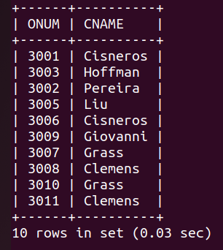

2. D1_nihar_84066>select ONUM,SNAME,CNAME from ORDERS,CUSTOMERS,SALESPEOPLE where SALESPEOPLE.SNUM=CUSTOMERS.SNUM and CUSTOMERS.CNUM=ORDERS.CNUM order by 1;

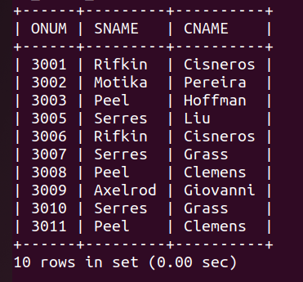

3. D1_nihar_84066>select CNAME,SNAME,COMM from CUSTOMERS,SALESPEOPLE where SALESPEOPLE.SNUM=CUSTOMERS.SNUM and SALESPEOPLE.COMM>0.12;
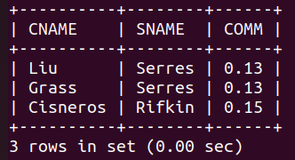

4. D1_nihar_84066>select ONUM,CNAME,AMT*COMM as commission from ORDERS,CUSTOMERS,SALESPEOPLE where SALESPEOPLE.SNUM=CUSTOMERS.SNUM and ORDERS.CNUM=CUSTOMERS.CNUM and CUSTOMERS.RATING>100 order by 1;

